Simulating Visual Impairments in a Virtual Reality Environment

Project Planning Document

DomINIC Reynolds – N0737367

**Introduction**

Virtual Reality immerses the user inside of a different world outside of our own, in which they can be whatever they want to be or what the designer wants them to be, I can use this to my advantage. I can use this medium to instead of show them how Visual Impairments can affect you, but let them experience and feel how Visual Impairments can affect you. I believe this would be a significantly better method of conducting this project, as it will lead to more successful results of people being more aware of the difficulties of living with a Visual Impairment.

Visual Impairments are a very common yet hard to understand disability. There are many different forms, which tend to be bundled into groups and people don’t know the differences between them and how they affect you differently. I will be building a simulator inside of a virtual reality environment which will let me simulate as many symptoms of Visual Impairments as I can so that the effects and complications of each can be demonstrated.

People in the care or design industry without visual impairments may struggle to incorporate consideration for people with visual impairments (*Goodman-Deane, Langdon, Clarkson, Caldwell, Sarhan, 2007*) into their job and routine, which can cause issues for their clientele. For example, if a designer does not take into account people with colour-blindness and uses the wrong colour scheme, then their product may be completely unusable to people with that type of colour-blindness, or if text is too small or hard to read, it may cause issues for people with poor eyesight. Also, if people in the care industry do not take into account their patients’ eyesight there may be risks of the patients not knowing of a danger or not being able to live their life properly.

Modern Virtual Reality Headsets also contain eye-tracking capabilities, which I will be able to use to more accurately simulate Visual Impairments such as Diabetic Retinopathy, in which, areas of vision may be completely lost or Floaters appear in the vision. Using the eye tracking, I can make these follow the user’s eyesight instead of being stationary, which would allow for the user to simply look around them and not provide a strong simulation of those Visual Impairments. Certain Headsets also contain front-facing cameras, through which I may be able to simulate the Visual Impairments, to allow for the user to experience a situation that they are used to through the eyes of a Visual Impaired Individual.

The goal of this project is to provide a strong tool for people to use to see how Visual Impairments can affect the Quality of Life for individuals afflicted, and to raise awareness and consideration for the Visually Impaired. The simulator could also be used by people in the Design or Care industries for them to be able to more accurately work with people with Visual Impairments as to not exclude them from their services, and help them more.

**Aims and Objectives**

AIMS:

* Produce a Virtual Reality Simulator of Visual Impairments.
* To raise awareness and understanding for the nature of Visual Impairments.

OBJECTIVES:

* Create a piece of Software which emulates an Environment.
* Produce shader algorithms to simulate Visual Impairments.
* Question Testers on their understanding of the nature of Visual Impairments, before and after experiencing the simulation.

**Tasks and Deliverables**

TASKS:

* Create a 3D Environment within Unreal Engine 4. (1 Week)
* Use either self-made or acquired assets to fill the environment, to make it more immersive. (1-3 Weeks, depending on choice)
* Build the environment to allow for display on a Virtual Reality Headset. (1 Week)
* Research Shader Algorithms and how to create them. (2 Weeks)
* Research Visual Impairments and how to accurately Simulate them. (2 Weeks)
* Create algorithms for different types of Visual Impairment (4 Weeks)
* Integrate Visual Impairment Shader Algorithms into the Virtual Reality Environment. (4 Weeks)
* Acquire Testers to experience the Simulation. (1 Week)
* Ask them about their prior understanding of Visual Impairments. (1 Week)
* Allow testers to experience the simulation. (2 Weeks)
* Question them again on if they understand more or are more aware of the nature of Visual Impairments (1 Week)
* Use information to draw final conclusion and produce report (2 Weeks)

A “Week” refers to a week’s worth of work, not 7 days.

I hope to be able to simulate as many Visual Impairments as possible with this Simulation. However, if I am to simulate colour-blindness accurately, there will be a large amount of matrix multiplications that will be needed to convert all of the colours within the environment to their simulated versions (*Brettel, Viénot, Mollon, 1997*). Due to the amount of calculations that will need to be done in real time. Depending on the processing capabilities of the computer, there may be a significant adverse effect on the smoothness of the simulation, which could make the testers no longer immersed and cause provide faulty results.

I expect that the conclusion of this project is that users, who experience my simulation, would gain a greater awareness and understanding for those afflicted by Visual Impairments. I feel confident in this assumption due to a similar project concluding with “[The Project] also demonstrates that, following exposure to the virtual environment, users of the simulation reported and demonstrated a greater awareness of the nature of visual impairments.” (*Lewis, Brown, Cranton and Mason, 2011*). Which is what my intentions of this project are.

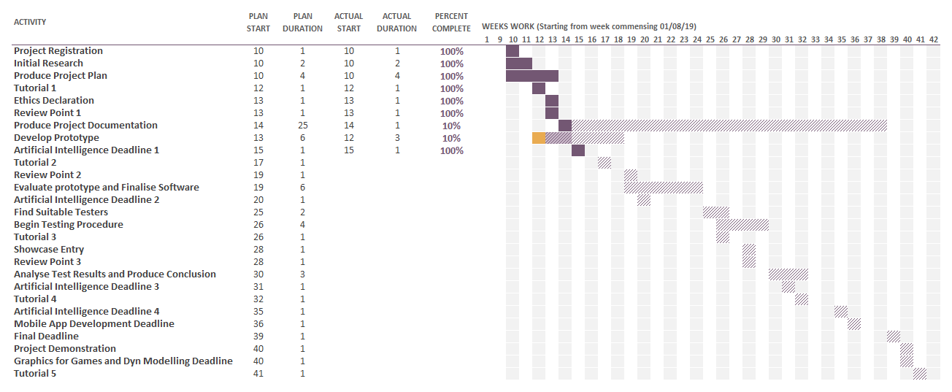

**Resources**

I will be using the Unreal Engine to produce the Environment, as it will allow me to produce a very basic environment quickly, and will handle the conversion to Virtual Reality for me, so that I will have more time to spend working on the simulation. According to a source, “Unreal Engine 3 was a suitable platform for developing an effective and accurate simulation of visual impairments” (*Lewis, Brown, Cranton and Mason, 2011*). Since that paper was published, Unreal Engine 4 has been released and is what I shall be using, but the base functionality has not changed and its viability should be unchanged.

For use in the Environment, I will be producing some models that the user can look around, this will require the use of a 3D modelling software, of which my choice is 3D Studio Max, as it is the program, I have the most experience with. This will allow me to make virtual versions of real-life objects, with my own choice of colours and patterns. I will be attempting to stick to recognisable colours, for example, a tennis ball would be luminous green, so that when people are seeing it through the simulation, they know what it should look like, and how it looks after being simulated. However, there is also a possibility that I could use premade assets from the Unity Store or UE4 Marketplace, which would mean that I could spend more time on other parts of the project, for example, simulating the visual impairments, which in my opinion is a significantly more important part of the project, and will take longer to complete. There are some assets that are free, as well as some that are licensed for educational use, but others would need to be paid for.

Some of the simulations that I would like to make require the user’s eye to be tracked to improve the accuracy of the simulation. To achieve this, I shall require the HTC VIVE Pro Eye, which has Eye Tracking capabilities, which were inspired by Tobii, who are the leaders in the field of Eye Tracking. However, this headset is not completely isolated, meaning that a Computer will also be required to run the simulation, and then relay the information to the headset.

**Risks**

|  |  |  |  |  |
| --- | --- | --- | --- | --- |
| Risk | Possible Causes | Chance | Severity | Solutions |
| Files Lost | Hardware Failure or Destruction.  Human Error. | Low | High | Keep multiple backups, on separate Hardware and Cloud Services. |
| Major Issues in Project Development | Complex, High-tier coding or mathematical requirements.  Lack of Experience / Knowledge. | Medium | Medium | Keep ahead of schedule and ask for help if needed. |
| Project Behind Schedule | Illness / inability to work  Lack of ability to continue or uncertainty of how to continue. | High | Medium | Keep ahead of schedule and ask for help if needed. |
| Depression, Anxiety, Stress or Similar Mental Issues | Being behind schedule, not looking after your health or not having enough free time | High | High | Look after health, stay on track, ask for help if needed and take plenty of time to yourself. |
| User experiences Epileptic seizures | User prone to Epileptic seizures.  Exposure to flashing lights or patterns. | Low | Medium | Reduce exposure to flashing lights and patterns. Ask about Epilepsy before subjecting to Virtual Reality. |
| User at physical risk during simulation | Not enough care when setting up test area.  User not being cautious of their surroundings. | Low | Low | Ensure the user has an abundance of space, without hazards, while they are in the Simulation. |
| Simulation does not provide real-world understanding | Users struggle to translate the simulation into the real world, not increasing understand of Visual Impairments. | Low | High | Add a real-world element to the simulation, such as a front-facing camera throughput to simulate the room the user is in. |
| Project Impossible | Simulating Visual Impairments does not provide an accurate representation of being Impaired. | Low | High | Provide evidence of this and use to plan an improved project with more attainable goals. |
| Incorrect Outcome | Simulation does not provide users with a greater knowledge or appreciation of Visual Impairments. | Medium | High | Rework simulation to help. Construct conclusion stating incorrect hypothesis. |

Risks of Virtual Reality, (*Korolov, 2014*).

**Legal, Social, Ethical and Professional Issues**

Any issues that may arise during my project should be monitored, as I should follow the British Computer Society (BCS) Code of Conduct (*British Computing Society, 2015*). However, BCS is not the only institute in the field of computing, so it would be advisable to also follow the Association for Computing Machinery Code of Ethics and Professional Conduct (*Association of Computing Machinery, 2018*), as well as the Institute of Electrical and Electronics Engineers’ Code of Conduct (*Institute of Electrical and Electronics Engineers, 2014*). The reason I should follow all of these, is due to the fact that if one society may have missed a certain topic, it is still an issue and should be addressed to as such.

“Have due regard for the legitimate rights of Third Parties” (*British Computer Society, 2015*), also “Ensure that you have the knowledge and understanding of the Legislation and you comply with such” (*British Computer Society, 2015*). The biggest issue would be the gathering and storing of user’s information, and specifically to follow the regulations of the Data Protection Act, 2018. Under the Data Protection Act, any person whose data I possess, has the right to know what it is being used for, the right to know what I hold, have incorrect data updated and to have data erased if wanted. I will follow this by explaining what the project is about and what conclusions I will be drawing, and what information shall be getting used in that. I will also provide any user with ways of contacting me if they require information updated or erased.

“Avoid harm … examples of harm include unjustified physical or mental injury” (*Association of Computing Machinery, 2018*). Since I am working in Virtual Reality there is a slight inherent risk for the user of the Simulation. Not being able to see, and having greatly reduced other senses and awareness of the surroundings can result in risk to the user. I will ensure, with the user, that they are aware of the risk and that the area is as safe and with the lowest risk of harm possible. The risk cannot be removed; however, the user will be aware of it and is fully within their rights to not take part if they are not happy with the precautions.

An ethical issue would revolve around whether or not I should use stock assets or make my own, since if I were to use the assets that are for educational use, I would not be able to continue work on the system, unless I paid for the licenses, or took them out and made my own. Making my own would mean there would be none of those issues, however, it would take more time. I consider this project a proof of concept and would be willing to use premade assets as they would allow for more time to be spent on more time-consuming components.

**References**

Association for Computing Machinery. (2018) Association for Computing Machinery Code of Ethics and Professional Conduct. [online] Available at: https://www.acm.org/code-of-ethics [Accessed 30 Oct. 2019]

Brettel, H., Viénot, F. and Mollon, J.D., 1997. Computerized simulation of color appearance for dichromats. *JOSA A*, *14*(10), pp.2647-2655.

British Computer Society. (2015) British Computing Society Code of Conduct. [online] Available at: https://cdn.bcs.org/bcs-org-media/2211/bcs-code-of-conduct.pdf [Accessed 30 Oct. 2019]

Institute of Electrical and Electronic Engineers. (2014) IEEE Code of Conduct [online] Available at: https://www.ieee.org/content/dam/ieee-org/ieee/web/org/about/ieee_code_of_conduct.pdf [Accessed 30 Oct. 2019]

Goodman-Deane, J., Langdon, P.M., Clarkson, P.J., Caldwell, N.H. and Sarhan, A.M., 2007, October. Equipping designers by simulating the effects of visual and hearing impairments. In *Proceedings of the 9th international ACM SIGACCESS conference on Computers and accessibility* (pp. 241-242). ACM.

Korolov, M., 2014. The real risks of virtual reality. *Risk Management*, *61*(8), pp.20-24.

Lewis J., Brown D., Cranton W. and Mason R. (2011). Simulating visual impairments using the Unreal Engine 3 game engine. In *2011 IEEE 1st International Conference on Serious Games and Applications for Health (SeGAH)* (pp. 1-8). IEEE.